Name: Ranit Pradhan

Roll no. AM.EN.U4ELC19028

Experiment No: 3 Date:10/02/21

**GENERATION OF DISCRETE TIME SIGNALS**

**AIM:**

To generate different types of discrete time signals using MATLAB program.

**Pre - lab Exercises**

Define the following signals in discrete domain

1. Define Unit Impulse signal.

 A signal which has infinite magnitude at time equal to zero only.

1. Define Unit Step Signal.

A signal with magnitude one for time greater than zero

1. Define Unit ramp Signal.

A signal whose magnitude increases same as time

1. Define exponential signals.

An exponential signal *is* a Mathematical function in form f (x) = ax, where “x” is a variable and “a”

1. Define complex exponential signal.

The complex exponential signals is defined for all *z*=*x*+*yi*∈C by *e^z*=*e(x*+*y)i*=*e^x*⋅*e^yi*=*e^x*(cos*y*+*i*sin*y*)

**Lab Exercise:**

Generation of signals in discrete time domain:

1. Generate & plot a unit impulse sequence

CODE;

n=-10:10;

y=zeros(length(n));

j=1;

for i=-10:10

if(i==0)

y(j)=1

end

j=j+1;

end

stem(n,y)

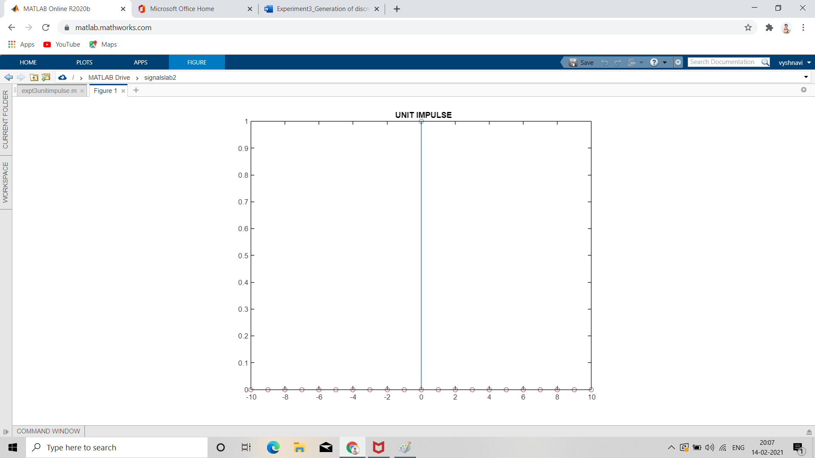

1. Generate & plot unit step sequence

CODE;

n=-10:10;

y=zeros(length(n));

j=1;

for i=-10:10

if(i>=0)

y(j)=1

end

j=j+1;

end

stem(n,y)

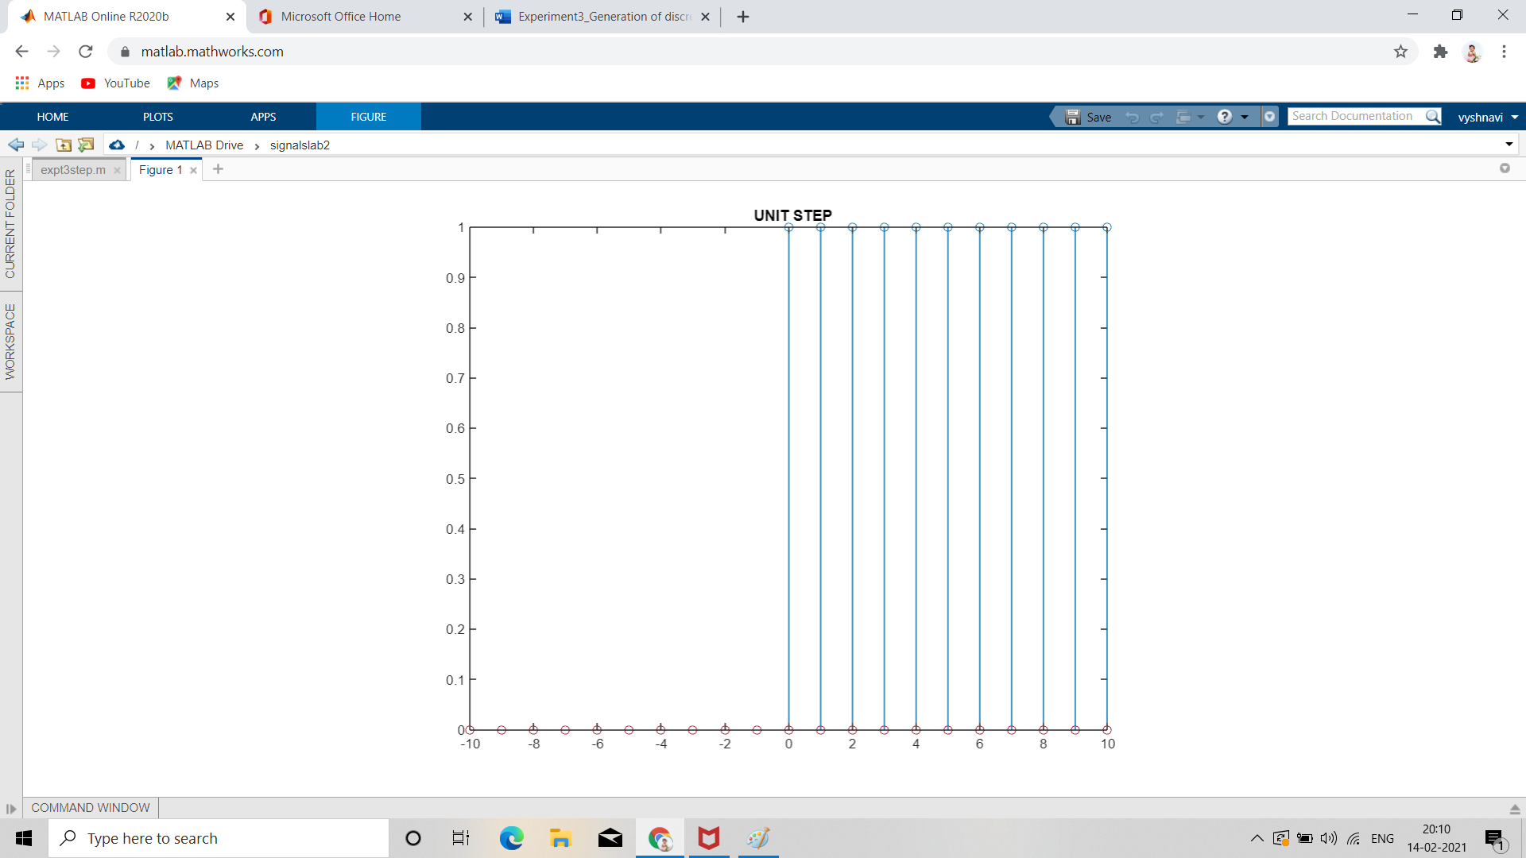

1. Generate and plot a ramp sequence.

CODE;

n=-10:10;

y=zeros(length(n));

j=1;

for i=-10:10

if(i>=0)

y(j)=i;

end

j=j+1;

end

stem(n,y)

xlabel('time')

ylabel('Y(t)')

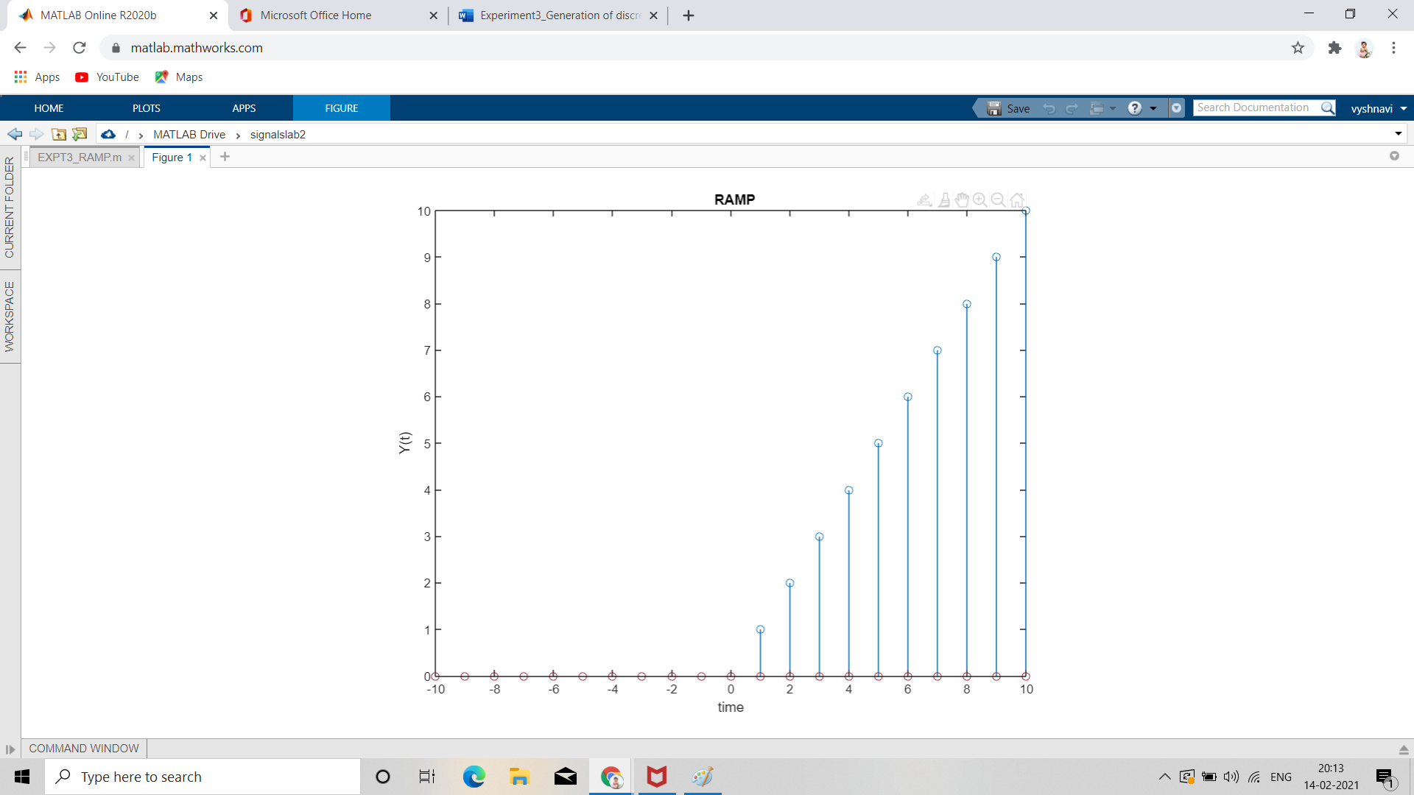

1. Plot the signal and check whether the signal is periodic. If periodic find the fundamental period.

CODE;

n=-10:10;

y=zeros(length(n));

j=1;

for i=-10:10

y(j)=cos(5*pi*i)-sin(5*pi*i);

j=j+1;

end

stem(n,y)

xlabel('time')

ylabel('Y(t)')

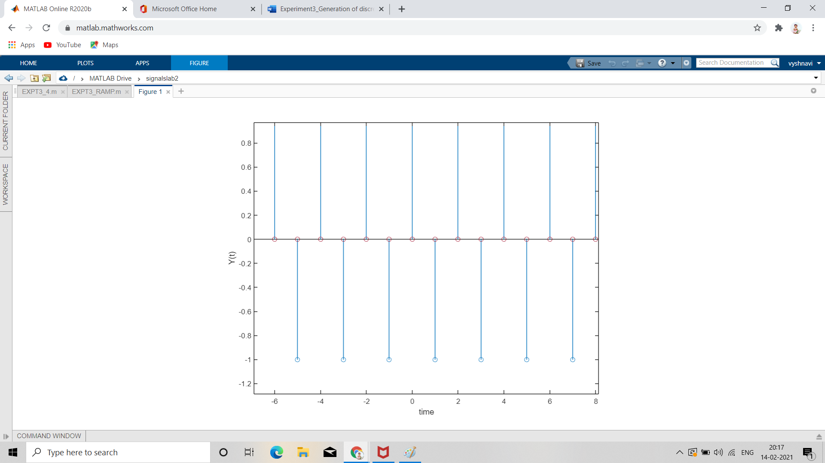

1. Plot 5 periods of the periodic signal given by .

CODE;

t= 0:19;

x=zeros(size(t));

j=1;

d=0;

for i=0:19

if i>=0 && d<4

x(j)=d+1;

end

j=j+1;

d=d+1;

if d==4

d=0;

end

end

stem(t,x)

xlabel("Time(sec)");

ylabel("X(t)");

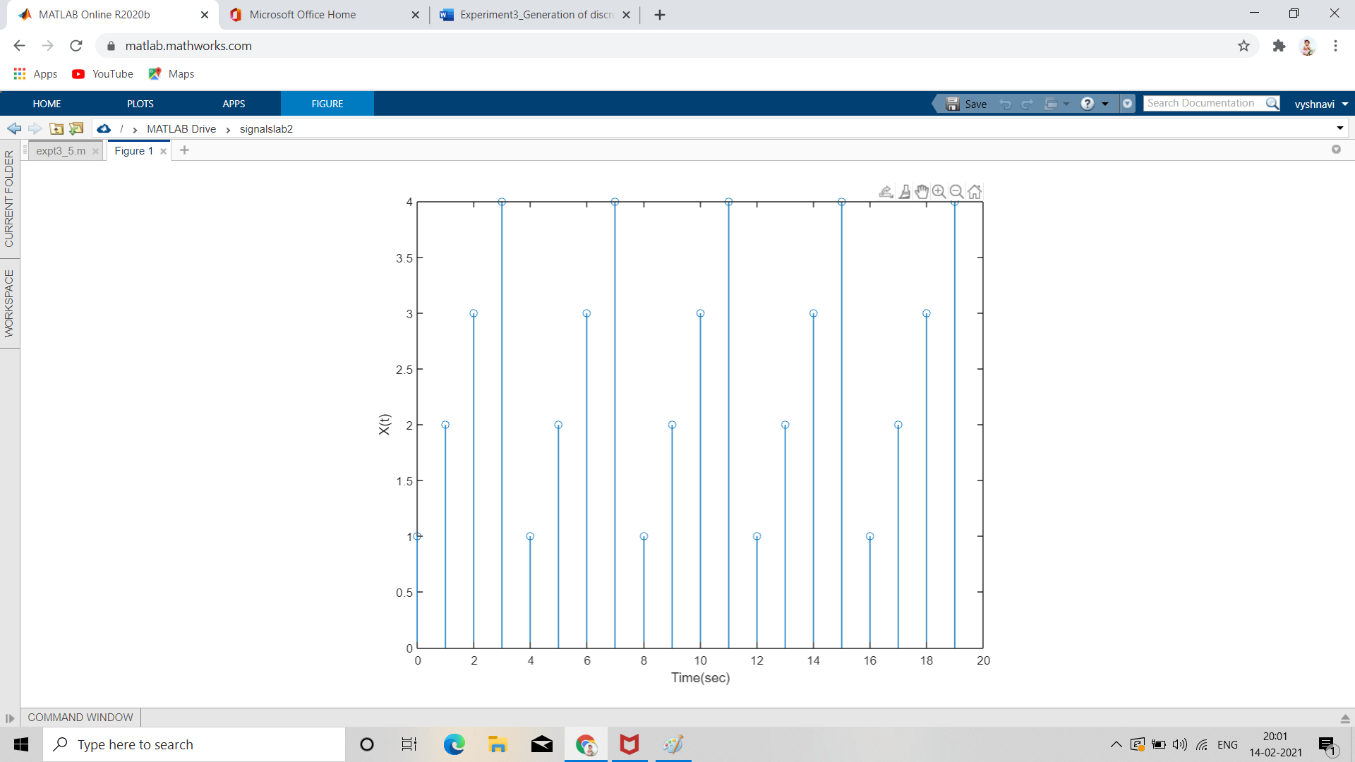

1. Generate and plot the complex exponential signal

CODE;

n=-10:10;

y=exp(1i*pi*n/3);

figure(1)

stem(n,real(n))

xlabel('time')

ylabel('Y(t)')

figure(2)

stem(n,imag(n))

xlabel('time')

ylabel('Y(t)')

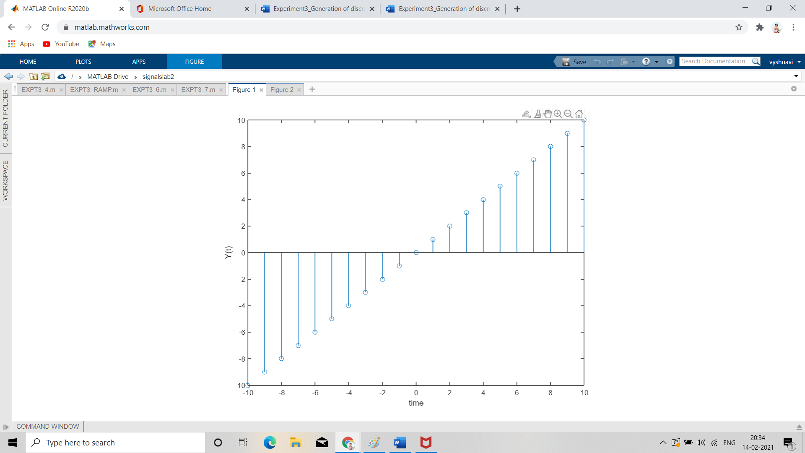

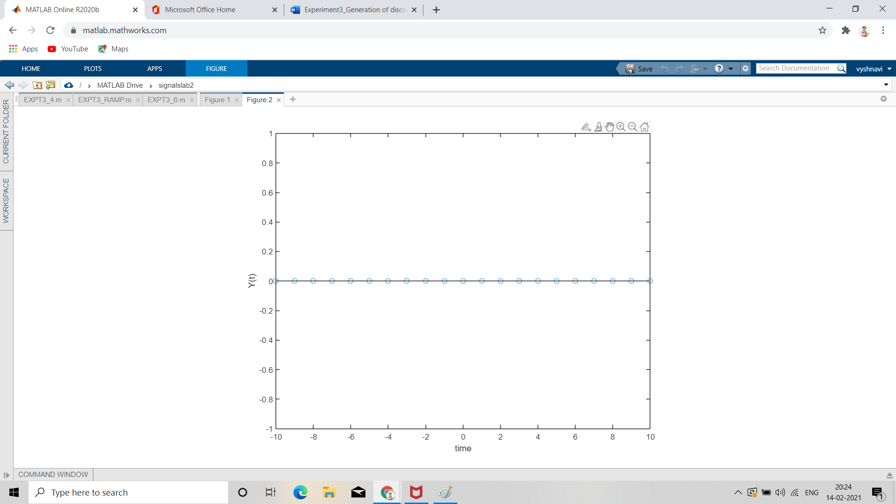

1. Generate the signals (a) (b) and plot the two figures using subplot command.

CODE;

n=-10:10;

x=5*((1/2).^n);

subplot(2,1,1);

stem(n,x)

x1=5*((2).^n);

subplot(2,1,2);

stem(n,x1)

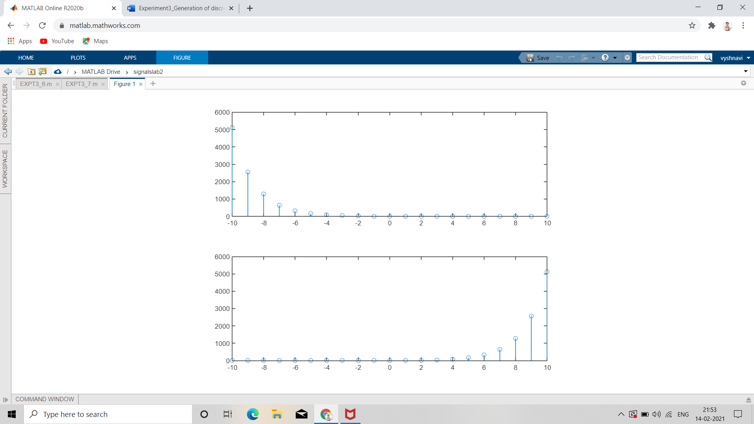

1. A discrete time signal x[n]= [3 2 1 0 1 1 3 2 3]. Plot the following signals.
2. x[n]u[n]
3. x[n]δ[n]
4. x[n]r[n]

CODE;

t= -4:4;

x=[-3 -2 -1 0 1 1 3 2 3];

j=1;

for i=-4:4

if i==1

x(j)=1;

end

j=j+1;

end

delta=t==0;

a=x.*delta;

figure(1)

stem(t,a)

%impulse

step=t>0;

b=x.*step;

figure(2)

stem(t,b)

%unit step

ramp=t.*step;

c=x.*ramp;

figure(3)

stem(t,c)

%ramp

1. x[n]u[n]

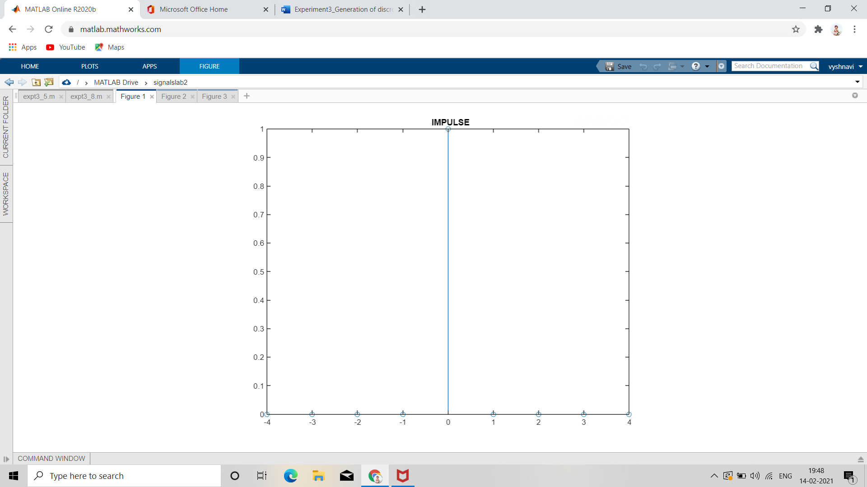

2.x[n]δ[n]

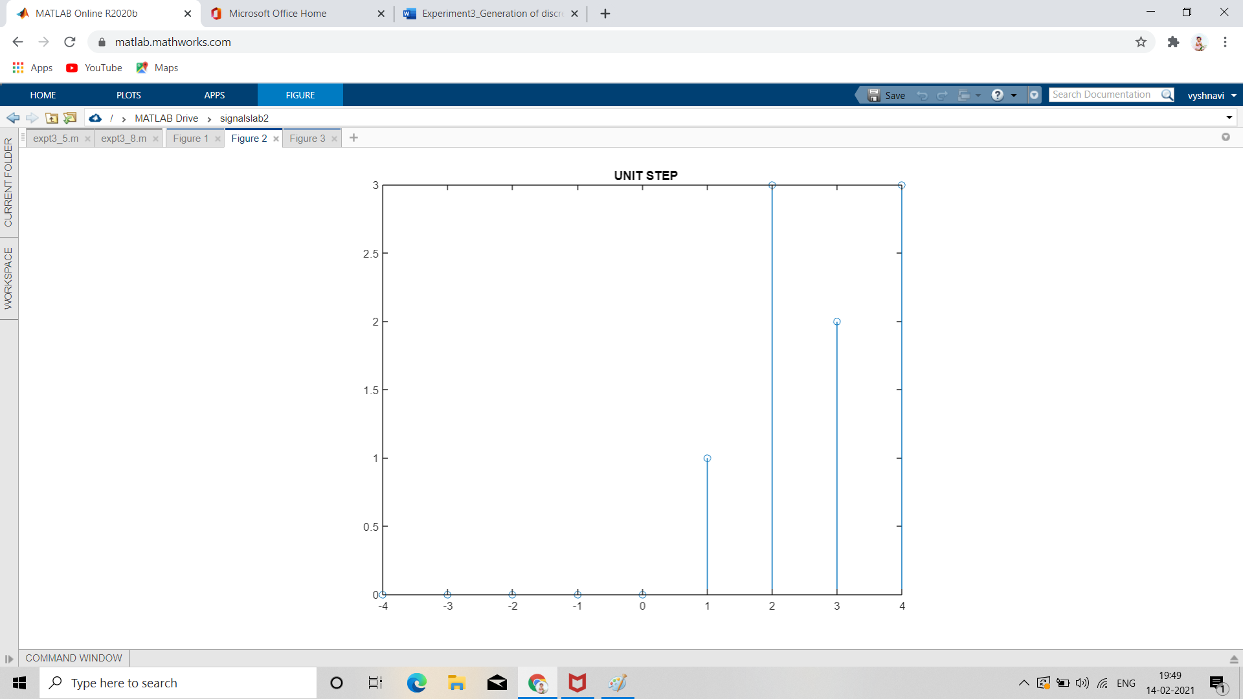

3. x[n]r[n]

